**Use Azure AI Vision Spatial Analysis to detect presence and movement of people in video**

You can use Azure AI Vision Spatial Analysis to detect the presence and movements of people in video. Ingest video streams from cameras, extract insights, and generate events to be used by other systems. The service can do things like count the number of people entering a space or measure compliance with face mask and social distancing guidelines. By processing video streams from physical spaces, you can learn how people use them and maximize the space's value to your organization.

Try out the capabilities of Spatial Analysis quickly and easily in your browser by using Azure AI Vision Studio.

**People counting**

This operation counts the number of people in a specific zone over time using the *PersonCount* operation. It generates an independent count for each frame processed without attempting to track people across frames. This operation can be used to estimate the number of people in a space or generate an alert when a person appears.



**Entrance Counting**

This feature monitors how long people stay in an area or when they enter through a doorway. This monitoring can be done using the PersonCrossingPolygon or PersonCrossingLine operations. In retail scenarios, these operations can be used to measure wait times for a checkout line or engagement at a display. Also, these operations could measure foot traffic in a lobby or a specific floor in other commercial building scenarios.



**Social distancing and face mask detection**

This feature analyzes how well people follow social distancing requirements in a space. The system uses the *PersonDistance* operation to automatically calibrate itself as people walk around in the space. Then it identifies when people violate a specific distance threshold (6 ft. or 10 ft.).



Spatial Analysis can also be configured to detect if a person is wearing a protective face covering such as a mask. A mask classifier can be enabled for the PersonCount, PersonCrossingLine, and PersonCrossingPolygon operations by configuring the ENABLE_FACE_MASK_CLASSIFIER parameter.

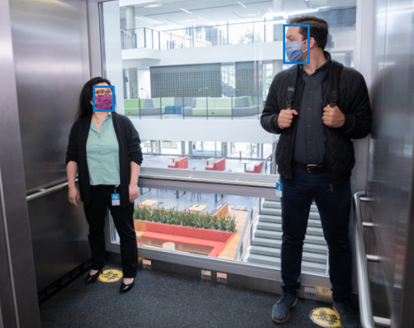

**Uses for Spatial Analysis**

The following are example use cases for which we designed and tested spatial analysis.

* **Shopper analysis** - A grocery store uses cameras pointed at product displays to measure the impact of merchandising changes on store traffic. The system allows the store manager to identify which new products drive the most change to engagement.
* **Queue management** - Cameras pointed at checkout queues provide alerts to managers when wait time gets too long, allowing them to open more lines. Historical data on queue abandonment gives insights into consumer behavior.
* **Building occupancy & analysis** - An office building uses cameras focused on entrances to key spaces to measure footfall and how people use the workplace. Insights allow the building manager to adjust service and layout to better serve occupants.
* **Minimum staff detection** - In a data center, cameras monitor activity around servers. When employees are physically fixing sensitive equipment two people are always required to be present during the repair for security reasons. Cameras are used to verify that this guideline is followed.
* **Workplace optimization** - In a fast casual restaurant, cameras in the kitchen are used to generate aggregate information about employee workflow. This is used by managers to improve processes and training for the team.
* **Social distancing compliance** - An office space has several cameras that use spatial analysis to monitor social distancing compliance by measuring the distance between people. The facilities manager can use heatmaps showing aggregate statistics of social distancing compliance over time to adjust the workspace and make social distancing easier.
* **Face mask compliance** – Retail stores can use cameras pointing at the store fronts to check if customers walking into the store are wearing face masks to maintain safety compliance and analyze aggregate statistics to gain insights on mask usage trends.

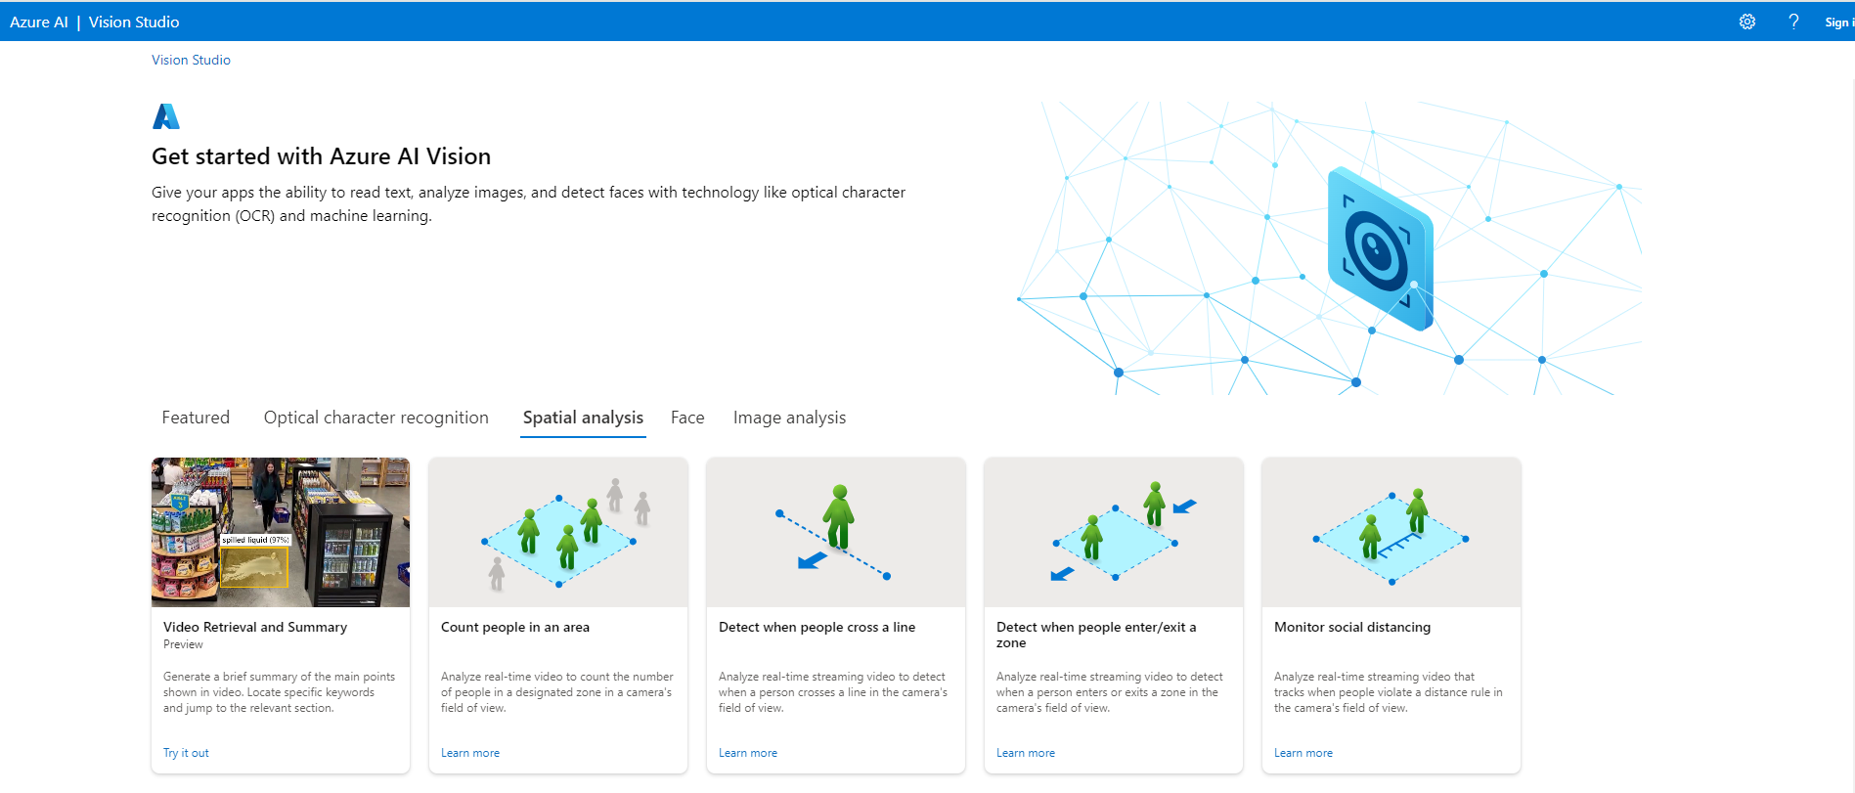

* 1. Detect when people cross a line (zone configuration to draw line)

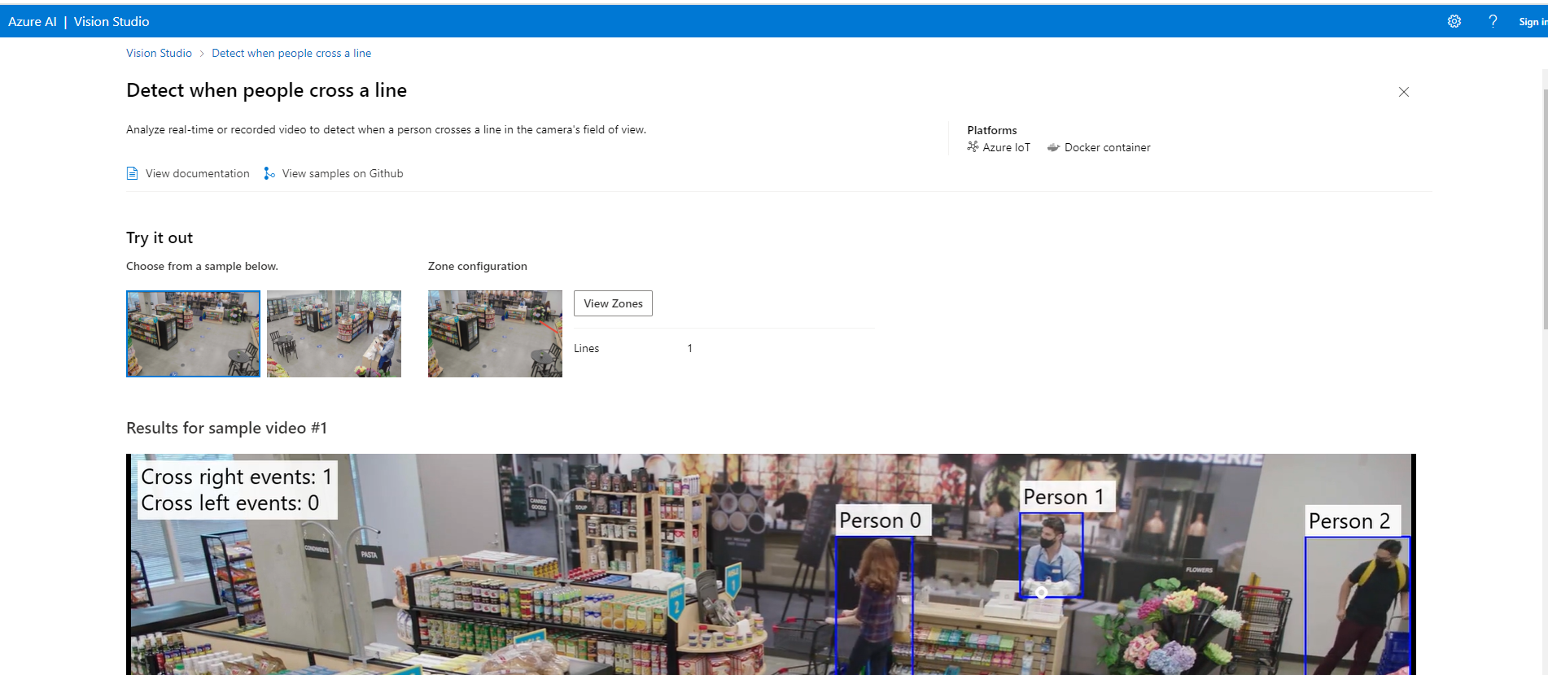

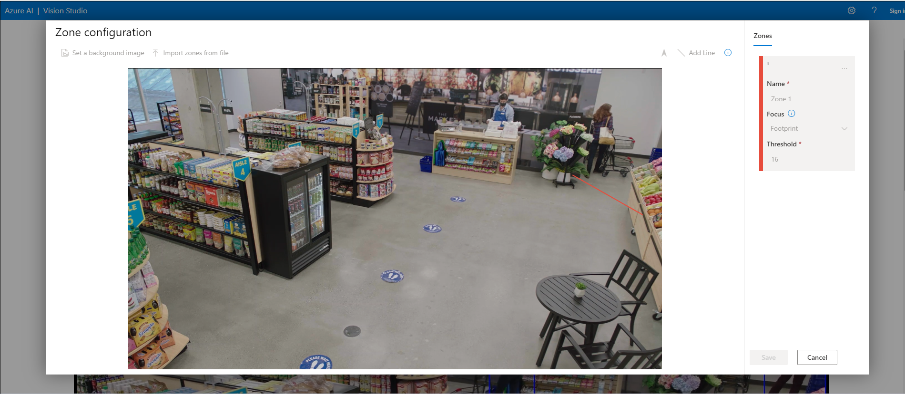

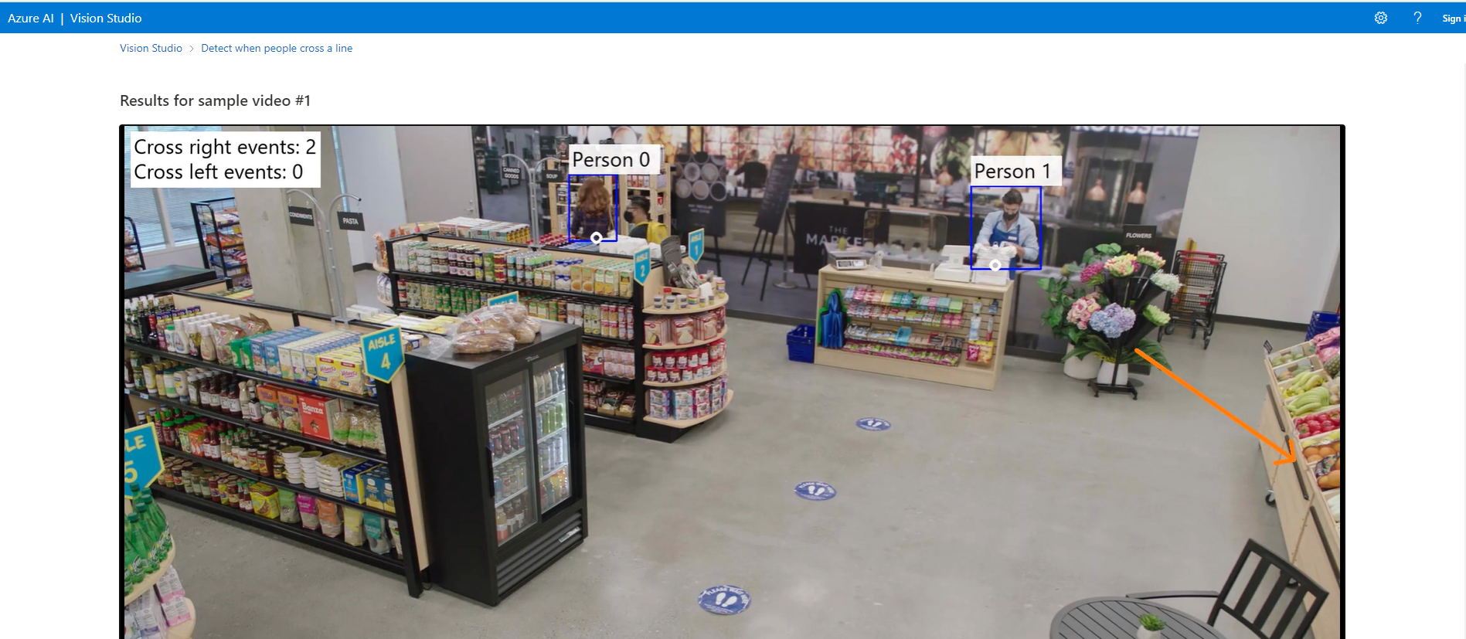

* 1. Video Retrieval and Summary

